Lab 1
Object Oriented Programming
Learning Objectives
Teacher perspective:
- Base the lab to maximum extent on students’ earlier learning in FCP course by avoiding new concepts for now such as constructors (and its types), access specifiers etc.
- Introduce the concept of setter/getter functions
  - Emphasize and demonstrate the importance of input validation in setter functions
- Introduce the concept of source-class and driver/test-class

Students’ perspective:
The students will be able to
- Implement classes in java along with their methods (behaviors) and attributes (properties)
- Create object of classes for using them
- Develop working programs in java by creating and using objects

Lab Walkthrough
Program 3.1
A sample Dog class.
Attributes are name and breed.
Methods are speak, sleep and eat.
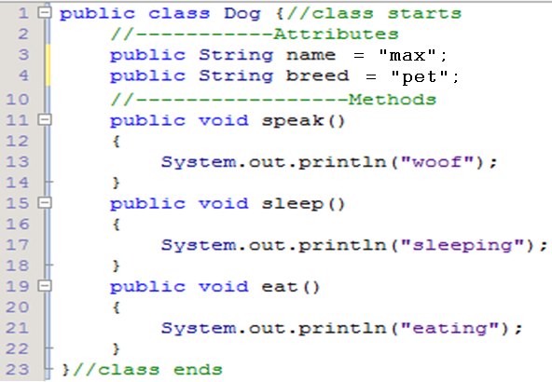

Experiment 3.1:
1. compile the above class (without main) using java filename.java. Does it compile? Why?
2. if above experiment is successful, run the compiled .class file. What happens? Why?
Program 3.2
A sample DogTest class (in separate file)
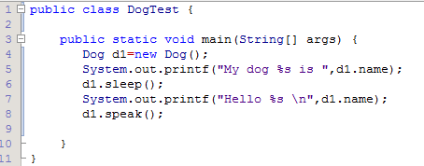
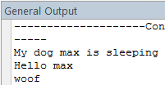
Lab Demo
Lab Demo 3.1.
The instructor will himself demonstrate the lab demo on multimedia.
Write a class Circle which will model the functionality of a Circle.
- Attributes
  - radius
- Methods
  - Setter function for radius
  - Getter function for radius
  - To compute area
  - To compute perimeter
Lab Task
Lab Task 3.1
- Design a class Rectangle which has following members:
  - Data:
    - length
    - height
  - Methods:
    - getArea
    - getPerimeter
- Test Rectangle inside the main function
Lab Task
Home Task 3.1
- Design a class QuadraticRoots which has following members:
  - Data:
    - a
    - b
    - c
    - root1
    - root2
  - Methods:
    - Setter functions (total 3)
    - Getter functions (total 3)
    - computeRoots
      - set root1 and root2 in this function (ignore iorta case)
    - displayRoots
      - display in format: (root1, root2)
- Test QuadraticRoots inside the main function.
  - Create an object of QuadraticRoots class.
  - Input instance variables a, b, c from user.
  - Call the computeRoots and displayRoots functions.

